CERTIFICATE OF ENROLLMENT

This is to certify that the learner with the information listed below is officially enrolled at Rizal High School.

000000000000 DOE, JANE M.

LRN & NAME:

GRADE & SECTION: 0-SAMPLE

SCHOOL YEAR: 20XX-20XX

Issued this 25th day of March, 2026 at Dr. Sixto Antonio Avenue, Caniogan, Pasig City, Metro Manila, Philippines.
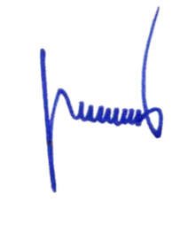

RICHARD T. SANTOS
Principal IV

SAMPLE

CERTIFICATE OF ENROLLMENT

This is to certify that the learner with the information listed below is officially enrolled at Rizal High School.

LRN & NAME:

GRADE & SECTION:

SCHOOL YEAR:

Issued this 00th day of Month, Year at Dr. Sixto Antonio Avenue, Caniogan, Pasig City, Metro Manila, Philippines.


RICHARD T. SANTOS
Principal IV

